**EMERGING METHOD FOR EARLY DETECTION OF FOREST FIRE**

**EMPATHY MAP**

**Observation Tower**

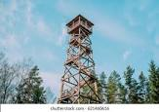

**Data Transmission**

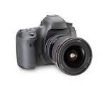

Logistic and Technical support

**Camera**

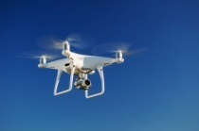

**UAV**

**Fire Detection**

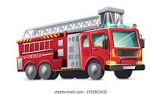

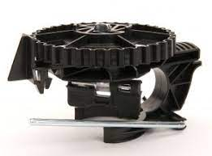

**Annoured tracked fire fighting vehicle**

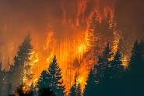

**Alarm**